**Darbhanga College of Engineering, Darbhanga**

**EEE Department**

**B.Tech [SEM VIII (EEE)]**

**QUESTION BANK**

**MODERN CONTROL THEORY**

Faculty: Mr.Akhil Mohammed KK

1. Define state, state variable and explain the significance of state variable analysis?

2. (a) A control system has a transfer function given by G(s) = S+3(S+1)(S+2). Obtain the canonical state variable representation.

(b) A system is described by

Find the transfer function?

3. a) Differentiate between eigen values and eigen vectors? b) Write a canonical form representation of linear operator? c) Define the concept of state? Write the state equations for dynamic systems?

4. a) What is the significance of the state transition matrix? State and prove the state transition matrix properties?

b) Obtain the state transition matrix for the state model whose A matrix is given by



5. a) Explain the concept of controllability and observability? b) Consider the system described by





Is this system is controllable and observable?

6. a) Explain the popular intentional nonlinear elements and their functionalities. b) Derive the describe function of saturation nonlinearity?

7. a) Explain the graphical method for constructing trajectories by using Isocline method? b) Obtain a phase plane portrait of the system given by



8. a) Define Lyapunovs stability and Instability Theorem.

b) Illustrate the generation of Lyapunov function by variable gradient method?

9. a) Define the state observer? Deduce the expression for full order observer? b) Consider the system defined by:



PART 2

1.a) Prove that similar matrices have the same characteristics polynomial and therefore the same eigen values? b) Find the eigen values and Jordan form representation for the following matrices?



2. a) Show that the solution to the homogenous state equation



is unique b) The following facts are known about the linear system

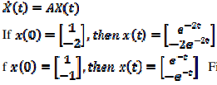

Find STM and hence A.

3. a) Explain the general concept of observability? Explain the observability tests for continuous time invariant systems?

b) Consider the system described by

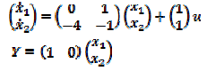

Is this system is controllable and observable?

4. The block diagram of a system with hysteresis is shown in Figure.1 Using describing function method, determine whether limit cycle exists in the system. If limit cycles exists, determine their amplitude and frequency.

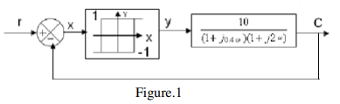

5. a) Explain the stability analysis of the linear continuous time invariant systems by Lyapunov second method. b) Illustrate the generation of Lyapunov function by Krasooviski’s method?

6. a) Define the state observer? Deduce the expression for reduced order observer? b) Consider the system defined by:



Show that this system cannot be stabilized by the state feedback control µ = −kx whatever matrix k is chosen.

7. Suppose that the system



is to be controlled to minimize the performance measure



Find a set of necessary conditions for solving optimal control using Hamiltonian formula of variational calculus.

PART3

1.Explain the concept of state?

2. Explain the physical significance of the concept of controllability and observability?

3.Discuss observability canonical forms of state model?

4. Describe the controllability tests for continuous time invariant systems.

5. Consider a system satisfying the differential equations



Is this system controllable?

6 a. Explain the popular nonlinearities.

b. List out the properties of nonlinear systems.

7. Derive the describe function of relay with dead zone.

8. Describe the stability analysis of Non-Linear systems through describing functions.

9. a Explain the concept of singular point.

b Consider the system described by the following equation:



Given the initial conditions 0 = 1, 0= 0, construct the trajectory starting at the initial point.

7.a. What are the different types of stability? Define and explain each of them with examples.

b.Suppose you are given a linear continuous time autonomous system, how do you decide whether a system is globally asymptotically stable?

8.a) Clearly explain the limitations of the classical control method. Define state, state variables and state space.

b) Develop the state model of Linear system and draw the block diagram of state model.

9.a) Derive the solution of homogeneous state equations.

b) Obtain the state model of the electrical network shown in figure below by choosing minimum number of state variables

10.a) State the duality between controllability and observability.

b) A Linear dynamical time invariant system represented by =Ax+Bu

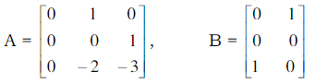

Find if the system is completely controllable.

11.a) Discuss about the Jump resonance and subharmonic oscillations in non Linear systems.

b) Explain describing function of saturation non-Linearity.

12.a) Explain the stability analysis of non Linear systems using phase trajectories.

b) Draw the phase trajectory of the system described by the equation



Comment on the stability of the system.

13.a) State and explain the Liapunov stability problem.b) Consider the second order system described by



The equilibrium state is the origin. Determine the stability of the system using Liapunov’s method.

14.a) What is the effects of Pole Placement by state feed back?b) Consider the system defined by

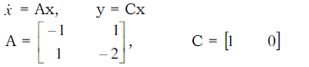

Design a full order state observer. The desired eigen values for the observer matrix are

µ1=-5,µ2=-5

15.a) What is the procedure followed for solving optimal control problem using Hamilton – Jacobi method?

b) Consider a system described by the equations



x1(0) = x2(0) = 1.Choose the feed back law



Find the value of k so that



is minimized.